3 Ways to Pay
HI-QI© Premade Layouts & Page Kits
By Scrappin Chick
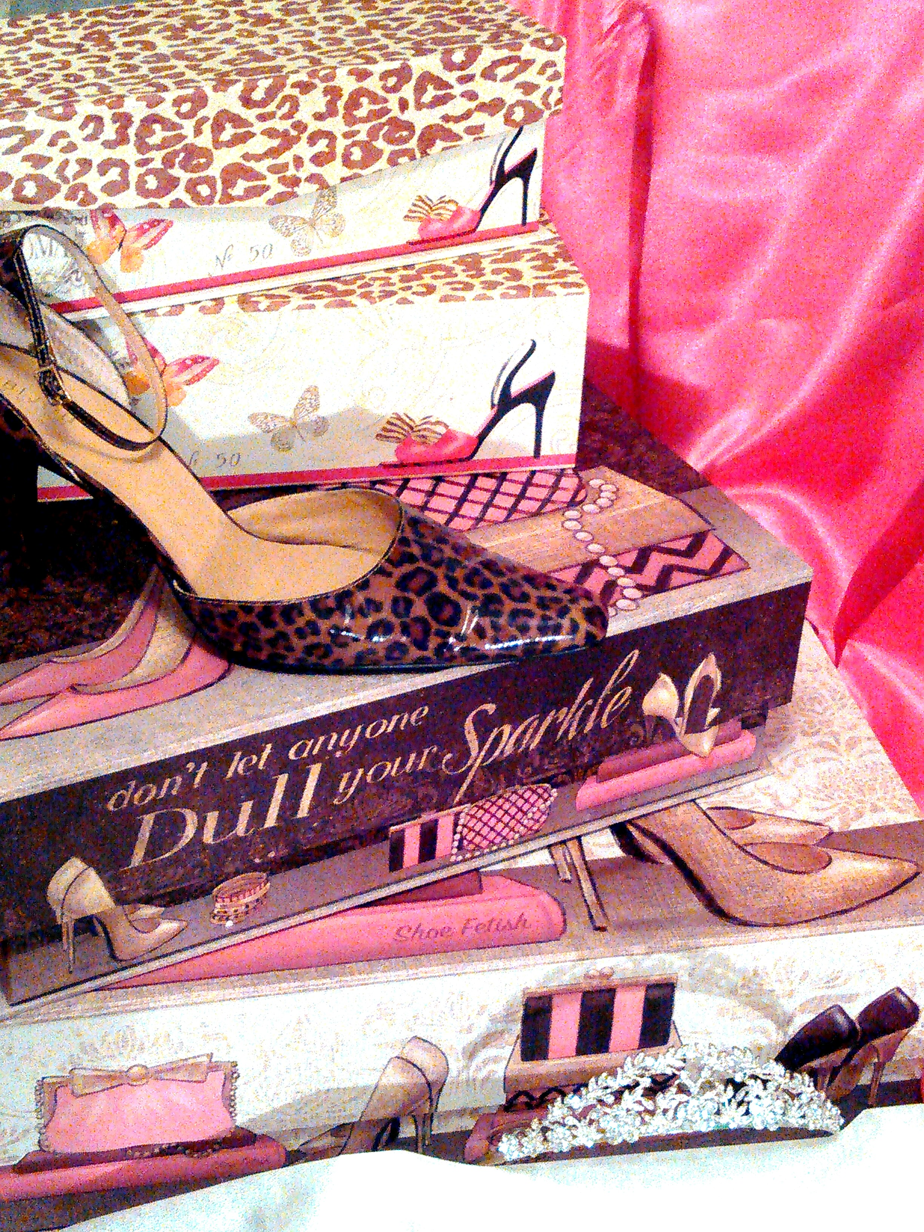
“Clean and Classy for Your Memories”
A Royal Scrap Club & Company Original©2003

Paypal Payment Information
Go to https://www.paypal.com/us/webapps/mpp/send-money-online
2.Enter email address: allwithgrace@hotmail.com
3.Enter the amount of Layout Kits Plus $5.00 for shipping
4.Click send money
5.******Make sure you select send to FRIENDS & FAMILY *******
If it asks for a name use Cyndi Pride

Snail Payment Information
(Check or Money Order)
Cyndi Pride
Royal Scrap Club & Company
152 Haynes Park Drive
Nashville, TN 37218

Personal Delivery
Please Ask
rscandcompany@gmail.com
HI-QI© Premade Layouts & Page Kits
By Scrappin Chick
“Clean and Classy for Your Memories”
A Royal Scrap Club & Company Original ©2003

About HI-QI Premade Layouts & Page Kits

EACH 12x12 (two) 2- page layout can be assembled as pictures or you can add your own twist. Kits are completely unassembled. Instructions for assemble included.

Optional Supplies NOT included: adhesive, sticky backed dimensional circles/squares, ink, gems, pearls, glitter glue, washi tape, and basic tools.

